PAYPAL INSTRUCTIONS
- 1. Sign up for a PayPal account or use existing account information
- 2. Click the Send Money tab
- 3. Enter an amount and type recipient’s email : stky2k@yahoo.com
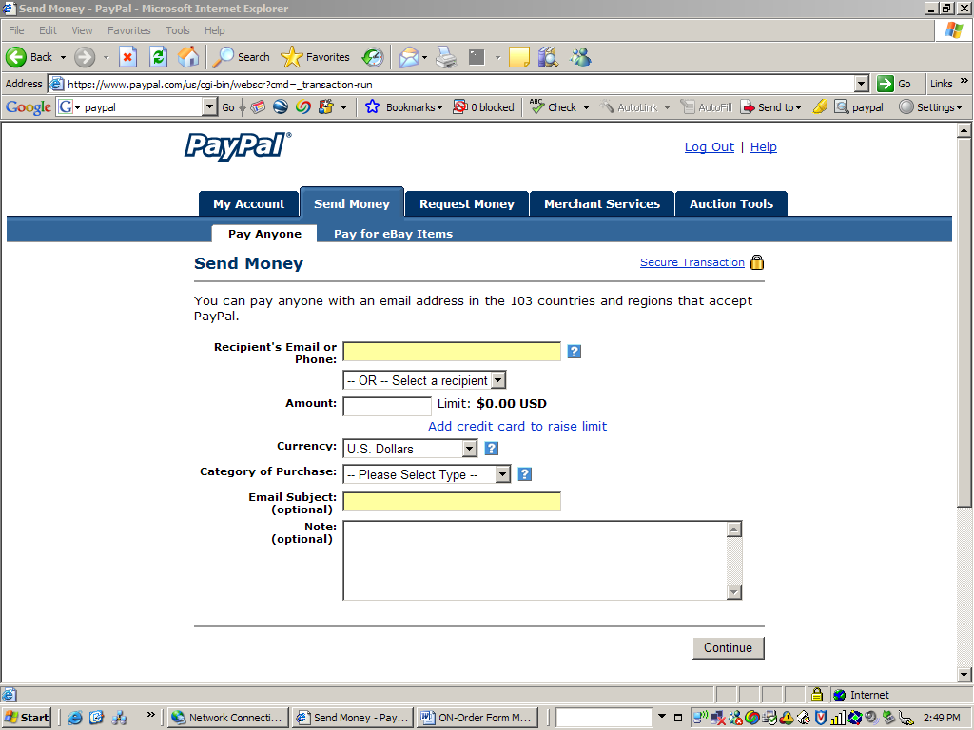
stky2k@yahoo.com

